Decorator Pattern

Introduction

* Decorators have the same supertype as the objects they decorate.
* You can use one or more decorators to wrap an object.
* Given that the decorator has the same supertype as the object it decorates, we can pass around a decorated object in place of the original (wrapped) object.
* The decorator adds its own behavior either before and/or after delegating to the object it decorates to do the rest of the job.
* Objects can be decorated at any time, so we can decorate objects dynamically at runtime with as many decorators as we like.

Definition: **The Decorator Pattern** attaches additional responsibilities to an object dynamically. Decorators provide a flexible alternative to subclassing for extending functionality.

**Design Principle: Classes should be open for extension, but closed for modification.**

Our goal is to allow classes to be easily extended to incorporate new behaviors without modifying existing code.

Motivation

As an example, consider a beverage in Starbucks. One may wish to add condiment **Mocha** or **Whip** to it, as appropriate. Assume beverages are represented by instances of the **Beverage** class, and assume this class has no functionality for adding condiments. One could create a subclass **BeverageWithCondiments** that provides them, or create a **CondimentDecorator** that adds this functionality to existing **Beverage** objects. At this point, either solution would be fine.

Now, assume one also desires the ability to add **Vegetables** to beverages. Again, the original **Beverage** class has no support. The **BeverageWithCondiments** subclass now poses a problem, because it has effectively created a new kind of beverage. If one wishes to add **vegetables** support to many but not all beverages, one must create subclasses **BeverageWithVegetables** and **BeverageWithVegetablesAndCondiments** etc. This problem gets worse with every new feature or beverage subtype to be added. For the decorator solution, we simply create a new **VegetablesDecorator** —at runtime, we can decorate existing beverages with the **VegetablesDecorator** or the**CondimentDecorator** or both, as we see fit. Notice that if the functionality needs to be added to all beverages, you could modify the base class and that will do. On the other hand, sometimes (e.g., using external frameworks) it is not possible, legal, or convenient to modify the base class.

Example

Starbucks Coffee

1. Take a House Blend Coffee object.
2. Decorate it with a Mocha object.
3. Decorate it with a Whip object.
4. Call the cost() method and rely on delegation to add on the condiment costs.

**Beverage Abstract Class**



**Beverage Concrete Class**





**Condiment Decorator abstract class**



**Condiment Decorator concrete class**





**Starbucks test class**



Example – Real World Decorator: Java I/O

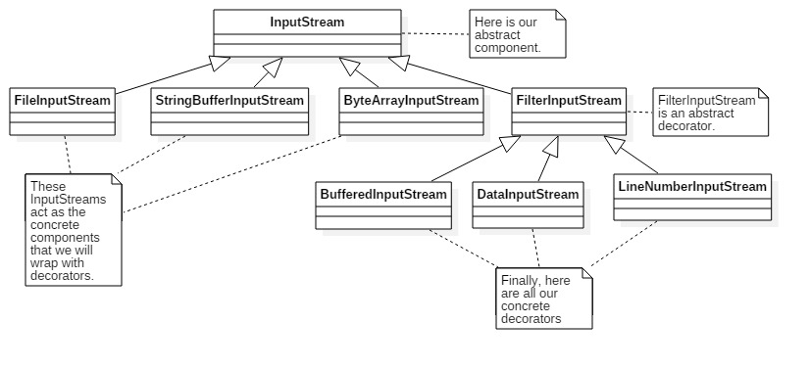

Writing out own Java I/O Decorator

Write a decorator that converts all uppercase characters to lowercase in the input stream. “MmMm” -> “mmmm”



Testing class

test.txt file content: I Know.

Output: i know.

Bullet Points

* Inheritance is one form of extension, but not necessarily the best way to achieve flexibility in our designs.
* In our designs, we should allow behavior to be extended without the need to modify existing code.
* Composition and delegation can often be used to add new behaviors at runtime.
* The Decorator Pattern provides an alternative to subclassing for extending behavior.
* The Decorator Pattern involves a set of decorator classes that are used to wrap concrete components.
* Decorator classes mirror the type of the components they decorate. (In fact, they are the same type as the components they decorate, either through inheritance or interface implementation.)
* Decorators change the behavior of their components by adding new functionality before and/or after (or even in place of) method calls to the component.
* You can wrap a component with any number of decorators.
* Decorators are typically transparent to the client of the component; that is, unless the client is relying on the component’s concrete type.
* Decorators can result in many small objects in our design, and overuse can be complex.